**DAS Configuration using Logical Volume Manager (LVM)**

**THEORY:**

**Here different HDD partitions can be logically grouped into one Volume Group & then can create different logical partitions as per the admin’s choice & these logical partitions can be mounted on the mount point.**

**This way it is easier to manage all the Hard Drive partitions easily & efficiently.**

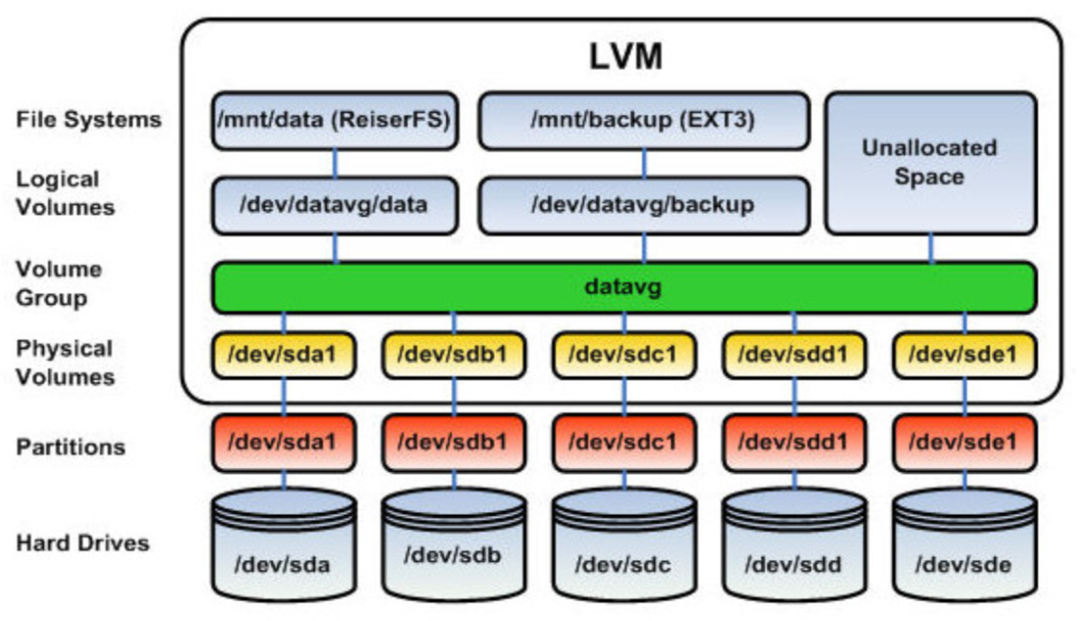

* **Attach 2 new HDDs to the linux System, assign them the table partition first, then start creating partitions of 10GB each. ( HDDs = /dev/sda, /dev/sdb)**

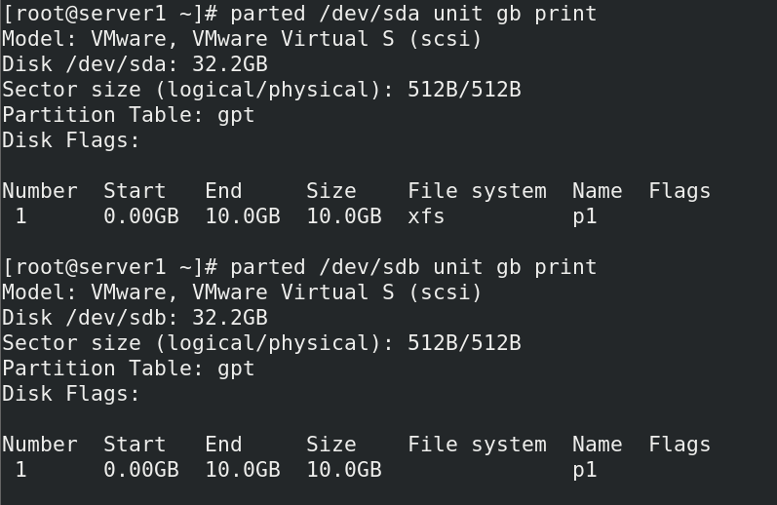

* **Use this command to let the OS know about the partitions that you have created.**



* **Now you need to process these partitions into LVM. First, you need to create physical volumes (PV) out of these partitions. In this step, we are making these partitions to behave has standalone logical HDDs.**

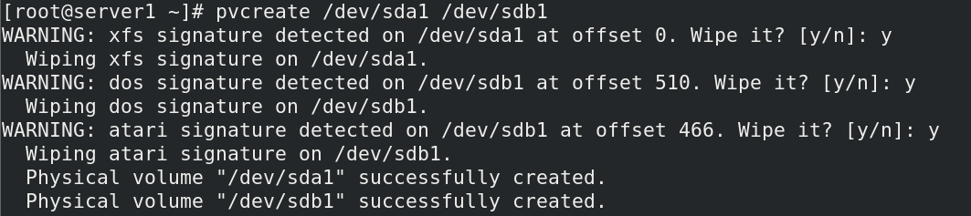

* **Verify the Physical Volumes that we have created.**

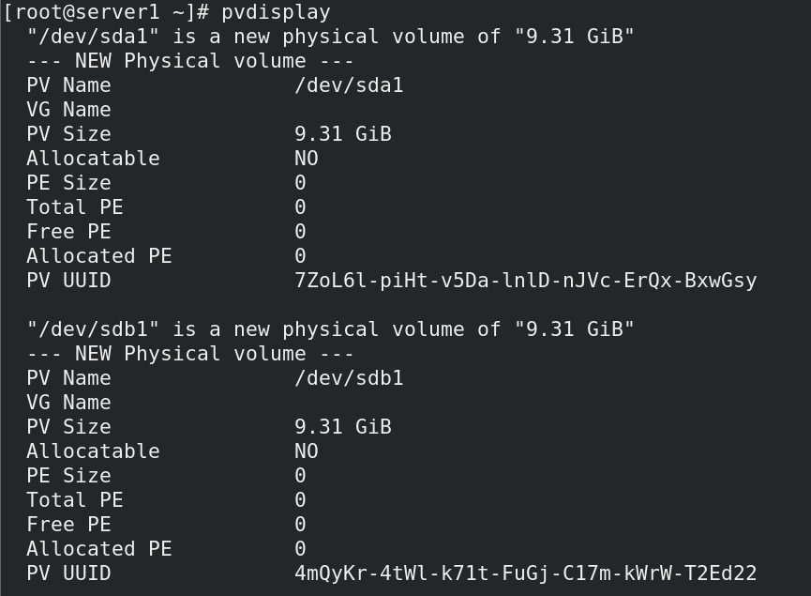

* **Secondly, you have to merge all these logical HDDs (i.e. Physical Volumes) into a single Volume Group (VG). Assume this as a physical HDD that you connect to the server to access storage.**



* **Verify the Volume Group that we have created.**

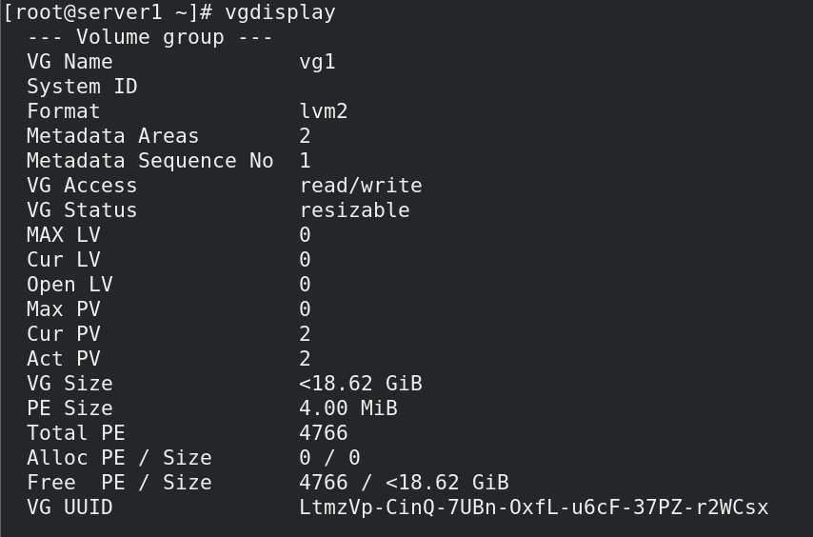

* **Now Start Creating Logical Volumes (LV) partitions from this Volume Group that you have created in the previous step. Asssume this as of you are creating physical partitions from the HDD.**

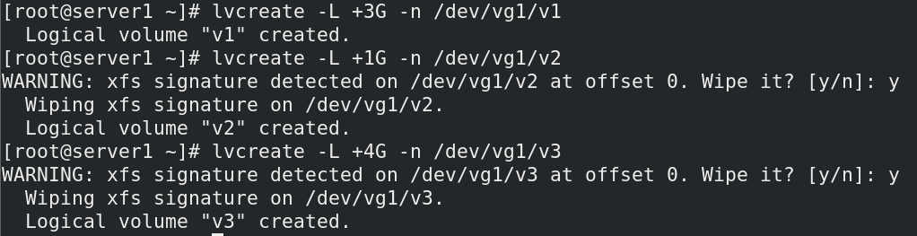

* **Verify the Logical Volumes that we have created.**

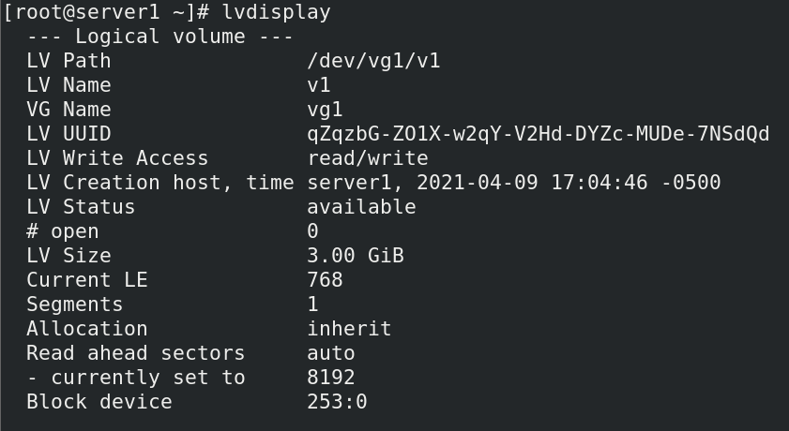

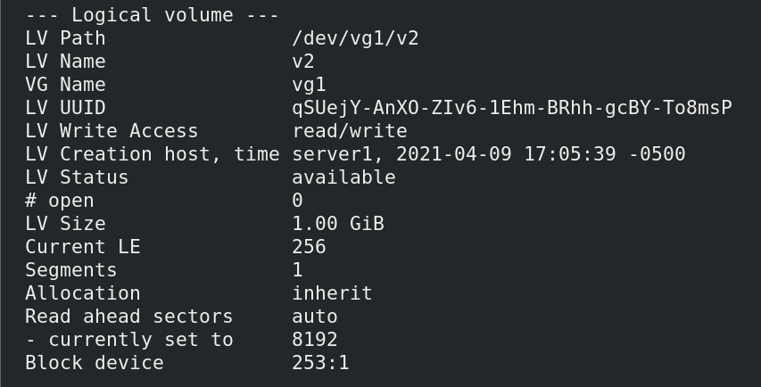

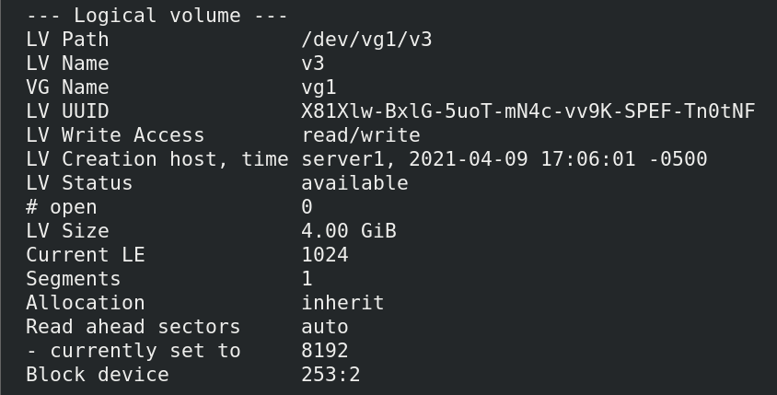

* **Now Format these Logical Volumes using XFS File System.**

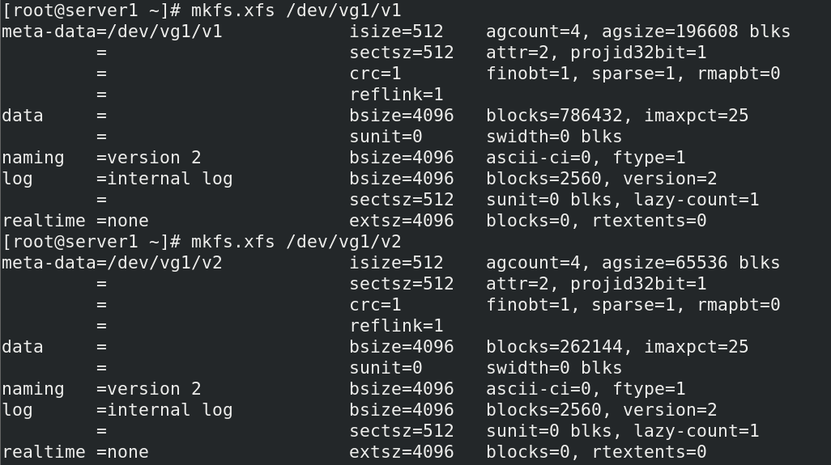

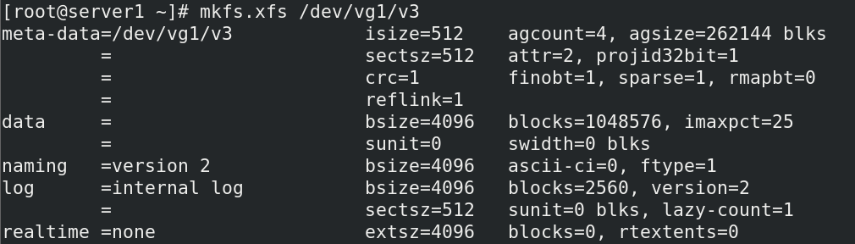

* **Now create 3 folders that you will use them as mount points for mounting our logical volumes.**



* **Now mount these Logical Volumes to the mount points (Folders that you have created)**

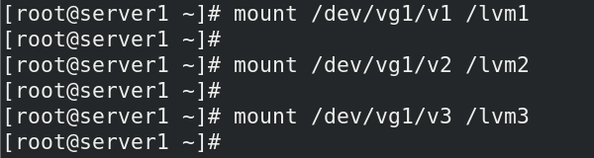

* **Verify the mount Logical partitions.**

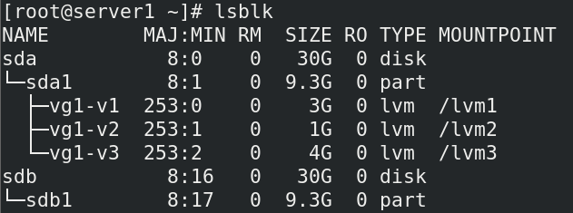

* **Now, let’s say if one logical volume size is not used to that extent, so here you can reduce its size & add it back to the free space of Volume Group (VG)**

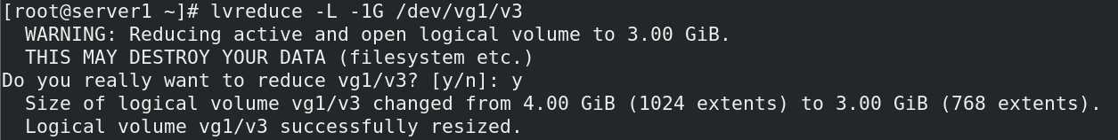

* **You can increase the size of a logical volume by adding more space from the free space of the Volume Group.**



* **You can verify the changes here that you have done. But there is a problem here, the changes that have done is not reflected here because this is done at the LVM level. So, the XFS file system that you are using on the logical volumes, they should also come to know about these changes.**

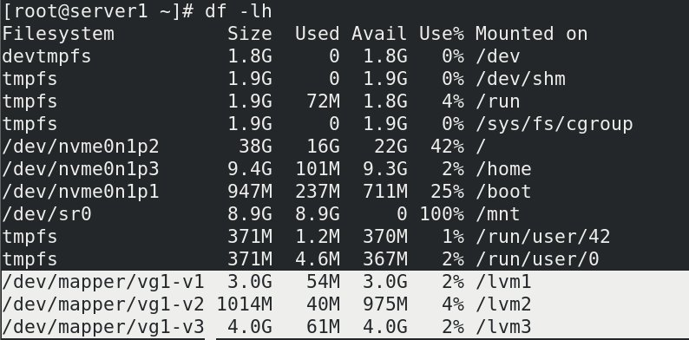

* **For the above part, use the following command.**

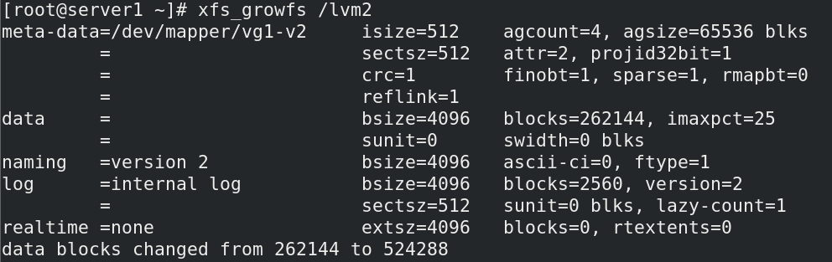

* **Now again verify the changes that you have done. It will reflect the proper size of each logical volume partition.**

